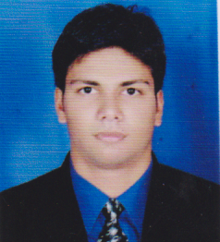
Samiulla Akhtar Jalgaonkar
A/P Nizampur, Raigad, M.S.
Phone: +91-8793323239
E-mail: jalgaonkar.sami@gmail.com

Career Objectives
To be a part of an organization where I can fully utilize my skills and make a significant contribution to the success of the employer and at the same time my individual growth.
Education
GRADE | UNIVERSITY/BOARD | YEAR OF PASSING | CLASS
B.E. PETROCHEMICAL | PUNE UNIVERSITY | 2016 | DISTINCTION
DIPLOMA (PETROCHEMICAL) | Dr. BATU, LONERE | 2012 | DISTINCTION
S.S.C. | MUMBAI BOARD | 2008 | HIGHER SECOND

Academic Project And Seminar
- Project title (B.E.): Design of Pyrolysis Reactor
- Seminar title (B.E.): Bioreactor
- Project title (Diploma): Biodiesel from waste cooking oil.
- Seminar title (Diploma): Desulphurization of flue gases.

Academic Training
- 1 month training at Vinati Organics in MAHAD, M.S.
- 15 days training at RCF Chembur.

Technical and Personal Skills
- Quantitative analytical abilities.
- Good knowledge of designing.
- Superior numerical abilities.
- Problem solving skills.
- Good communication skills.

Software Skills
- AutoCAD
- Aspen Hysis
- HTRI
- Basic skills in MATLAB
Strengths
- Quick learner.
- Adaptive to changing technologies.
- Quick decision making.
- Can accept responsibility.
Personal Details
- DOB: August 13th 1992
- Birthplace: Nizampur, Maharashtra, India
- Marital Status: Single
- Languages known: English, Hindi, Urdu, Marathi, Arabic (Read)
- Hobbies: Playing outdoor games, reading books, travelling
- Address: A/P Nizampur, Taluka Mangaon, District Raigad, M.S. (402120)

Declaration
- I hereby declare that all the information furnished above is true to the best of my knowledge.

(Samiulla Akhtar Jalgaonkar)

