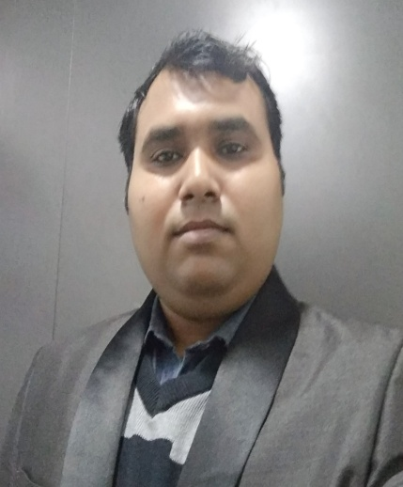

**Objective:** To pursue a career in design in technical field, that will enhance my knowledge base and professional development and put to use my technical knowledge, and inter-personal skills for personal growth and growth of the organisation.

**Professional Abridgment:**

* A skilled individual with keen interest in the field of Mechanical Engineering.
* Proficient in grasping new technical concepts and utilizing them in an effective manner.
* Strong technical, analytical, problem solving and organizational abilities.

**Educational Qualification:**

|  |  |  |  |
| --- | --- | --- | --- |
| **Qualification** | **Batch** | **Name of Institution** | **Percentage** |
| B.Tech - Mechanical  Engineering | 2011-+ | IIMT Engineering College, Meerut.Affiliated to U.P. Technical University, Lucknow | 71% |
| (12th) Intermediate | 2006 | R.N.C.K.V.M.I.C.R SARKARI Santkabir nagar | 72.4% |
| (10th) High school | 2004 | G.I.C. Faizabad (U P Board) | 59.5% |

**WORK EXPERIENCE:**

* **OMEGA-ICEHILL PVT LTD, UTTARAKHAND, INDIA**

(OMEGA THERMO PRODUCTS JOINT VENTURE) (ISO 9001:2008)

Stainless steel heat transfer equipments manufacturer (Chillers, Ice Machine etc) and solution providers to heat transfer technology in the field of water, beverage, food, pharmaceuticals, chemical, paper and pulp, dairy and marine industries.

**DESIGNATION: Assistant Engineer:** March - 2012 to March - 2017 (5 year)

**Assistant Manager**: March - 2017 to Till date (1 year )

**Job Responsibilities**: **Overseeing Production, Design , Development and**

**Programming.**

* Preparing **Auto Cad** drawings for customers and also for Shop floor.
* Preparing 3D Assembly using **solid works** for fabrication assembly.
* Preparing laser cutting and laser welding **CNC programmes** for production of laser welded pillow plates.
* Design of equipments as per **ASME SEC VIII DIV-1**.
* Development of New part and assembly.
* Preparing **BOM.**
* Preparing costing sheet for various engineering products.
* Preparing **P&I** diagram and **G.A**. Drawing.
* Looking after day to day activities, production schedules, maintaining the Management Information System, implementing quality tools for optimum output and allocating work by work allocation charts for achieving production targets.
* Keeping control over activities and analysing processes for stabilization thereby ensuring smooth operations.
* Minimizing bottlenecks for high productivity with maximization of manpower, materials and machines.
* Appraising the prevalent production system/processes, identifying loopholes if any and undertaking result-oriented measures for elevating them and documenting the same.
* Brainstorming for the team to identify and solve problem.
* Analyzing and scheduling work process, looking after mass productivity.
* Execute and monitor Production activities.
* Meet the targets defined for Production, Quality and Safety.
* Handling despatch of shipment.
* Raw material planning for Production activities.
* Handling Secondary Job Work Activities and dealing with the customer on daily basis.

**AREAS OF EXPOSURE:**

Insight in the manufacturing of laser welded pillow plates (dimple plates) and fabricated assembly, Planning of Raw material and Man power, preparing 2D- Auto Cad Drawings, 3D Solid Works Drawings , CNC Programming, Costing of Various engineering products.

**COMPETENCIES:**

* Proficient in documentation and reports .
* Exposure to handling and working with large group of individuals to achieve required targets/goals.
* Knowledge of reading and understanding technical drawings and deriving data from the same.
* Exposure to 2D/3DComputer Aided Designing.
* Highly dedicated and hardworking team player, utilizing overall skills of the team to achieve tasks with optimum efficiency.
* Exposure to Auto Cad, Laser welding programming and CNC programming.
* Ability to handle multiple tasks with ease and give desired outcome.

**PERSONAL DETAILS:**

**Date of Birth** : 1st  April 1989

**Marital Status** : Married

**Nationality** : Indian

**Permanent Address** : VILL- Baskhoriya , P/O. Kurthiya (Bansi) , DISTT - Siddharth Nagar (Uttar Pradesh ) PIN - 272153

**Current Address** : F -7 , Malik Colony , near Kappor General store, Udham Singh Nagar, Rudrapur , Uttarakhand, India, 263153

**Alternative Contact Number** : +919412832659

**Hometown** : Siddharthnagar, Uttar Pradesh

**Languages** :Hindi, English