**Umer** Ashraf Faki 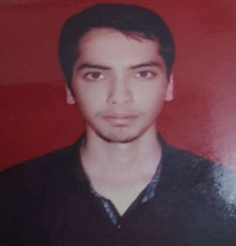

102, Hill Zone Tower,

Behind Old Nasheman Colony,

Kausa,Mumbra, Mob:- +917666617333

**Dist:-Thane.** E-Mail:- umer.fakih@ymail.com

**Career** Objective:

To establish myself as an enterprising Technical professional, keeping pace with current and upcoming technologies, where I can give my best of output potentials, Qualities & can explore to learn new things.

Professional Experience:

* Currently working in KAMAR INFRASTRUCTURE PVT LTD. TALOJA as a CAD DESIGNER from 12th February 2018.

Educational Qualification:

|  |  |  |  |
| --- | --- | --- | --- |
| **Qualification** | **University/Board** | **Percentage%** | **Year** |
| **S.S.C**  **(Queen Mary’s High School)** | **Mumbai** | **87.27%** | **March-2010** |
| **H.S.C**  **(Nes Ratnam Junior College of Science)** | **Mumbai** | **67.33%** | **February-2012** |
| **B.E(Mechanical)**  **(Yadavrao Tasgaonkar College of Engineering & Management)** | **Mumbai** | **5.87 CGPA** | **May-2016** |

Technical Competencies:

* MS Office.
* AutoCAD Mechanical 2D.
* Solidworks.

Personal Profile:

Name : Umer Ashraf Faki

**Father’s Name**  **:** Ashraf Dawood Faki

Date of Birth : 20 May 1994

Sex : Male

Marital Status : Single

Nationality : Indian

Religion : Islam

Languages Known : English, Hindi, Marathi, Konkani

Declaration :

I hereby conclude that the information provided above is authentic and true to the best of my knowledge and benefit.

PLACE: MUMBRA UMER ASHRAF FAKI