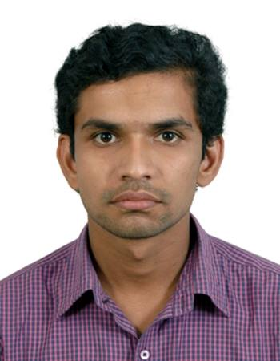**RESUME**

NIKHIL KASHTE

**Contact No:** +91-8149540188

**E-mail:** [nk366054@gmail.com](mailto:nk366054@gmail.com)

**OBJECTIVE:**   
Seeking a career that is challenging and interesting, and lets me work on the leading areas of technology, a job that gives me opportunities to learn, innovate and enhance me skills and strengths in conjunction with company goals and objectives.

**ACADEMICIA:**

1. Secured 64.73% Mechanical engineering from Nagpur University in the year 2014.
2. Secured 65.83% in Higher Secondary School Certificate, of Maharashtra State Board, in the year 2009.
3. Secured 80% in Secondary Schooling Certificate, of Maharashtra State Board, in the year 2007.

**TECHNICAL QUALIFICATION:**

1. Participated in “iSENSOBOTZ on AVR” workshop conducted by ARK techno solution in the year 2012, where I had hands on experience on making various robots.
2. Participated in various automobile workshops where I had learned about various Engines.

**WORK EXPERIENCE:**

**Job Title:** Maintenance Engineer

**Employer:** V G PATIL ENGINEERS AND CONTRACTORS

**Period:** Oct 2014 to Nov 2015

* Planning and undertaking scheduled maintenance
* Diagnosing faults & repairing equipment
* Supervising engineering and technical staff
* Maintaining statistical and financial records
* Ensuring compliance with health and safety legislation
* Creating maintenance procedures, managing stocks and supply equipment.

**PROJECT:**

1. **During Bachelor Of Engineering (Final Project- Final Year)**

* **Project Name:-** COUNTER FLOW TYPE HEAT EXCHANGER
* **Details: -** this project can be applied to refrigerator, air conditioning, car radiator, intercooler and chemical plant to increase their efficiency.

1. **During Bachelor Of Engineering (Mini Project- Second Year)**

* **Project Name:-** GENEVA MECHANISM
* **Details: -** The Geneva is a gear mechanism that translates a continuous rotation into an intermittent rotary motion.

**COMPUTER PROFICIENCY:**

1. Thorough knowledge of Microsoft Office
2. Knowledge about CAD/CAM.

**EXTRA CIRRUCULAR:**

1. Vice President of MESA committee of Vidya Niketan Institute of Engineering and Technology
2. Member of Rotract club of Vidya Niketan Institute of Engineering and Technology**.**
3. Representing College has Secretary at RTMNU, Nagpur.

**INTERPERSONAL SKILL:**

1. Ability to rapidly build relationship and set up trust.
2. Ability to work to deadlines and cope with different situation.
3. Ability to be strong team player and to work effectively at different levels of organization.

**HOBBIES AND INTRESTS:**

1. Travelling, Social networking, Adventurous sports etc.
2. Learning different language and working on projects.

**EXPECTED REMUNERATION :**

As per company norm

**PERSONAL DETAILS:**

Father’s Name: Anil Kashte

Date of Birth: 4th October 1991

Gender: Male

Marital Status: Unmarried

Address: 15, Shivkripa, Shiv Square, Near Sanjay Video, Washim - 444505.

**DECLRATION:**

I do hereby declare that the above information is true to the best of my knowledge.

**PLACE : Nikhil Kashte**

**DATE: (Signature)**