**Sanket Pandit**

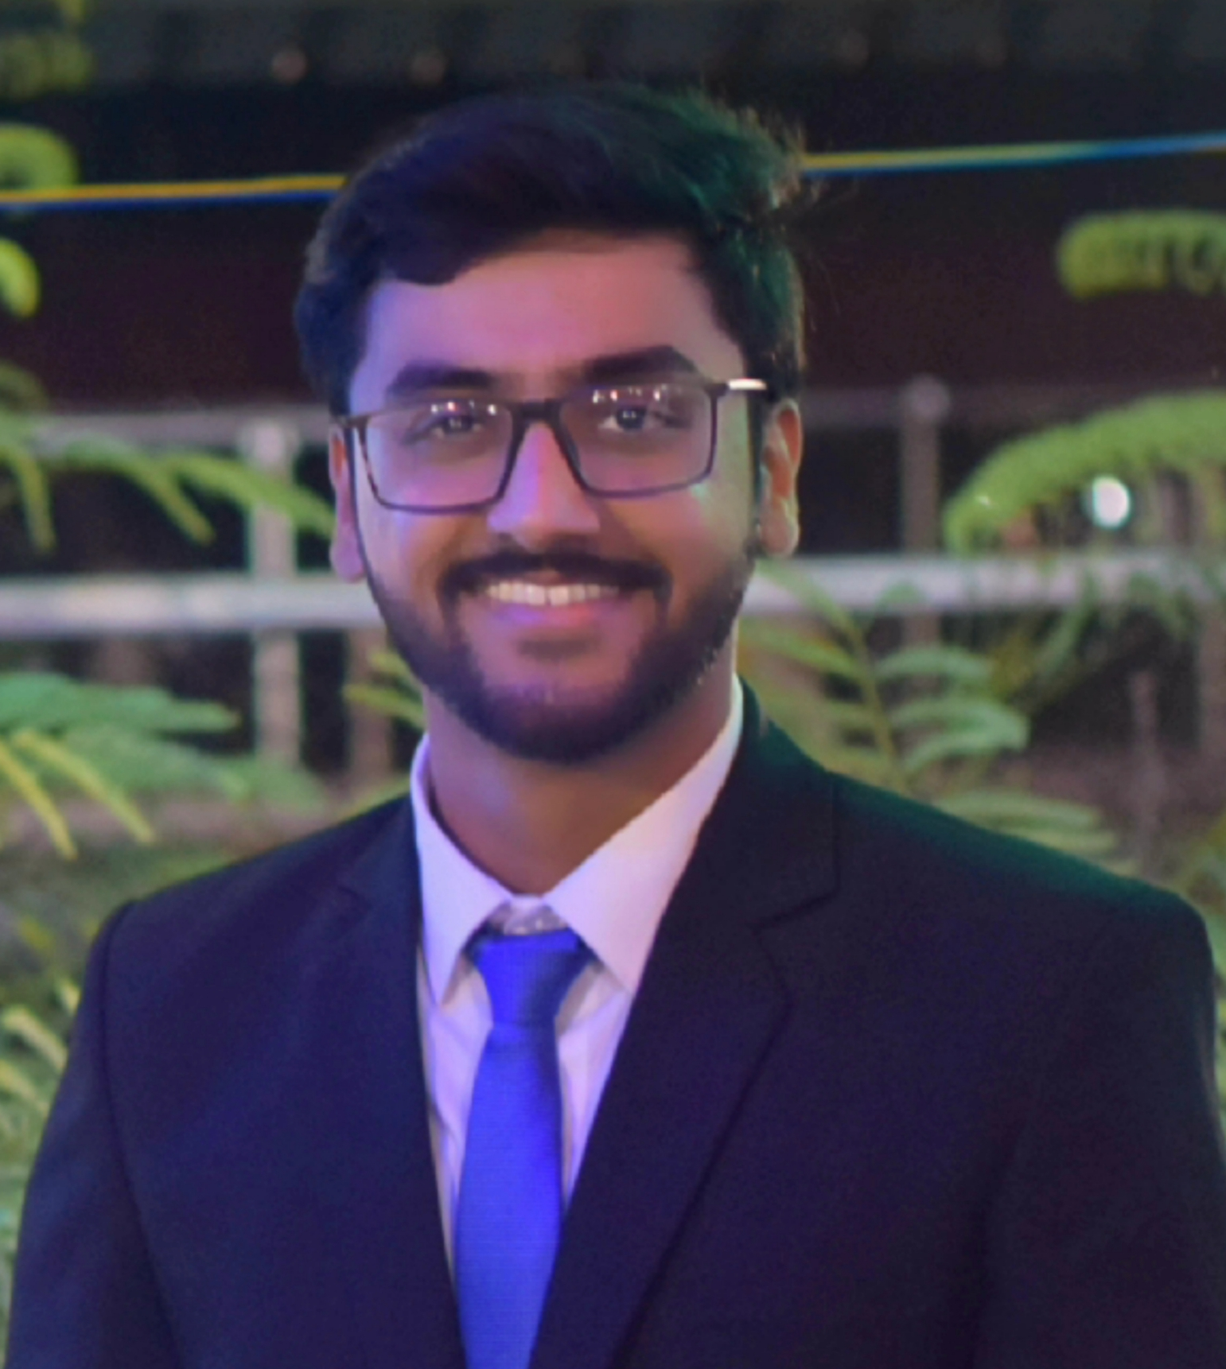

**Email:** [**panditsanket29@gmail.com**](mailto:panditsanket29@gmail.com)

**Mobile:** +91-7021363175

|  |  |  |  |  |  |
| --- | --- | --- | --- | --- | --- |
| **Career Objective:**  Seeking an opportunity in a reputed organisation which recognizes and utilizes my potential to leverage my basic understanding of chemical engineering to become a fundamentally sound and magnetic professional. | | | | |  |
| **Education:** | | | | | |
| **Qualification** | **School/College** | **Year of Passing** | **Percentage/ CGPA** | **Board/ University** | |
| B.Tech Chemical Engineering | Vellore Institute of Technology, Vellore | 2018 | 8.38/10 (CGPA) | Vellore Institute of Technology | |
| 12th | SVPT’s Saraswati Vidyalaya | 2014 | 84.4% | Maharashtra State Board | |
| 10th | VPM’s Sau. A. K. Joshi Eng. Med. School | 2012 | 93.09% | Maharashtra State Board | |

|  |  |  |  |  |  |  |  |
| --- | --- | --- | --- | --- | --- | --- | --- |
| |  | | --- | | **Software/ Simulation skills:** |  * **Tools learnt:** Aspen plus, Aspen Dynamics, Unisim, SolidWorks, MS Office * **Programming:** basic knowledge of MATLAB  |  | | --- | | **Research Activities and Academic Projects:** |  * **Performance Investigation of Dividing Wall Reactive Distillation Column with Vapor Recompression in Formic Acid Production Process**   Simulation of the patented process and further process intensification using Aspen Plus v8.8(paper published in “Chemical Engineering and Processing: Process Intensification”).  (<https://doi.org/10.1016/j.cep.2017.11.016>)  *September 2016 – March 2017*   * **In situ ultrasonication aided biodiesel production from microalgae.**   A Department of Science and Technology, Government of India (DST) funded project to improve the biodiesel production process from algal biomass using ultrasonication.  *January 2018– April 2018*   * **In situ ultrasonication aided biodiesel production.**   Final year project under **prof. Dipesh Patle** to improve the biodiesel production methods from castor oil via ultrasonication.  *December 2017 – January 2018*   * **Plantwide Control of Formic Acid Production Process**   Simulation based plantwide control of the above mentioned Formic Acid process using a heuristic approach under the guidance of **prof. Dipesh Patle**.  *January 2017 – March 2018*   * **Simulation and Control of CSTR in Formic Acid Production Process using Aspen Plus.**   As a partof the course “Process Instrumentation and Control” under the guidance of **Prof. Dipesh S. Patle**.  *August 2016-November 2016*   * **Simulation system for Phthalic Anhydride production using Aspen Plus**   As a part of the course “Petrochemical Technology” under the guidance of **Prof. Dipesh S. Patle**.  *August 2016 – November 2016*   |  | | --- | | **Industrial Training/ Workshops:** |  * Vocational Trainee at **Reliance Industries Ltd. (Dahej Manufacturing Division) (RIL-DMD)**. In addition to the basic plant overview, successfully completed a project suggesting improvements and optimization of energy consumption resulting in lower working costs in the process PET-3. * Attended workshop on Process Simulation using Aspen plus conducted by SCALE, VIT University.  |  | | --- | | **Courses of Interest:** |  * Modelling and Simulation, Mass Transfer, Process Technology, Process Control and Process Plant Economics  |  | | --- | | **Achievements:** |  * Received an **Achiever Certificate** from **VIT University** for participation and achievements in various competitions as well as technical paper presentations in various conferences for the Academic Year 2016-17. * Obtained **Best Student Project Award** on VITAA Day 2017. * **Co-authored a technical paper** presented in the 69th Annual Session of Indian Institute of Chemical Engineers held at AC Tech., Anna University, Chennai. * Received **Certificate of Merit** by **National Chemical Engineering symposium**, TKM College, Kerala.  |  | | --- | | **Extra-curricular Activities:** |  * **Won** awards (Best delegate, High Commendation and Special Mention) in **all the Model United Nations (MUN) conferences participated in** (VITMUN’14, JNTUH’16, YLGC’16 and VITMUN’17). * **Member** of and participated in a week long Special Camp conducted by **NSS-VIT (National Service Scheme)**. * **Organiser** of **graVITas 2017** (Annual Technical Festival of VIT). * **Student Co-ordinator** and **Student Volunteer** of **graVITas 2016** and **graVITas 2015** respectively. * **Deputy Operations Officer** for **Spartans’ Association of Youth** (NPO) from October, 2015 – February, 2016. * **Deputy Marketing Officer** for **Spartans’ Association of Youth** (NPO) from September, 2015 – February, 2016. * **Core Committee Member** of clubs and chapters like VIT Spartans, Debate Society VIT and Uddeshya VIT.  |  | | --- | | **Personal Information:** |   **Date of Birth :** 29/08/1996  **Nationality :** Indian  **Blood Group :** B+ve  **Hobbies :** Reading social philosophy and non-fiction, watching political and biographical dramas, movies and TV series, watching Oxford Union debates, Ted talks and following cricket.  **Languages known:** English, Hindi, Marathi, Gujarati, German (Basic). |