 | Janak Kumar Lohare  Address: A/14 VIDHI, Shree Niketan 2 Society, Zadeshwar road Bharuch - 393001  Phone: 9503130139, 8830534889  E-mail:janaklohare@gmail.com  Janakkumar89@live.in  Date of Birth: 04/10/1992 | 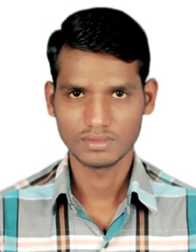

Career Objectives

I would be grateful if better career opportunity would provide to me. Looking for an opportunity in EPCC for chemical, petrochemical industries so that I can apply my basic engineering and petroleum refining knowledge. it will beneficial for me as individual and social growth in the corporate world for respected organization.

Experience

- WANKSONS CHEMICAL INDS. PVT. LTD. Panoli
Joined at – 20/01/2018
Designation – Technical Officer
Job role - Technical data analysis of production and Troubleshooting in Plant.
Maintaining daily production report and norms calculations.
Making the PFDs for new and existing processes in plant.
Making mass and energy balance calculations for processes.
Cost estimation of products and Projects.

- PUDUMJEE PAPER PRODUCTS LIMITED, Thergaon Pune.
Served at: 16/10/2017 to 15/01/2018.
Designation – Shift engineer trainee

Education

M.Tech. PETROCHEMICAL ENGINEERING (30 Oct. 2017)
- Post Graduate Degree - 69.41 %

- Laxminarayan Institute of Technology, Nagpur

- Rashtrasant Tukadoji Maharaj Nagpur University

B.Tech CHEMICAL ENGINEERING (26 June 2014)
- First Class with 72.86 %

- Priyadarshini Institute of Engineering and Technology, Nagpur

- Rashtrasant Tukadoji Maharaj Nagpur University

HSC (2010) HSS School Pathakhera Dist. Betul M.P. (89%)
SSC (2008) HSS School Pathakhera Dist. Betul M.P. (83.6%)

Industrial Training
- Internship training in RCF Limited, Chembur Mumbai in 2012.

- Workshop on chromatography, mass spectrograph at VNIT (Nagpur) 2014.
Projects
- True Boiling Point Distillation of Waste Transformer Oil. (M.Tech.)
- Study of Batch Distillation for non-ideal binary system. (M.Tech.)
- Sorption study of trans aconitic acid by using powdered activated carbon. (B.Tech.)

Seminar
- Seminar on FT Synthesis. (B.Tech.)

- Seminar on Coking. (M.Tech.)

Hobbies and Strengths

- Team Leading Quality.

- Skilled professional

- Positive Attitude with quick learning ability.
- Hard working

Technical and Analytical Skills
- MS Office, EDraw.
- Basic MATLAB 7.9, CHEMCAD and AutoCAD,
- Handling knowledge of FTIR and UV Spectrophotometer.

I hereby declare that the above-mentioned information is correct up to my knowledge and I bear the responsibility for the correctness of the above-mentioned particulars.

Date: 20/09/2018 Janak Kumar Lohare

